Project Report
On
Synapse Drive - ADAS Advanced Driver Assistance System:
A Hybrid Fuzzy-LSTM Approach for Real-Time Collision Risk Assessment


Session:

Supervised by:
Priyanka Gupta
(Assistant Professor)

Submitted by:
Student names and enrolment numbers
Arnav Shukla E23CSEU0889
Manit Kumar E23CSEU0898
Yug Yash Nirwan E23CSEU0904

BTECH Computer Science Engineering
SCHOOL OF COMPUTER SCIENCE ENGINEERING AND TECHNOLOGY,
BENNETT UNIVERSITY

CERTIFICATE

We hereby declare that the research project titled “ADAS — Advanced Driver Assistance System: A Hybrid Fuzzy-LSTM Approach for Real-Time Collision Risk Assessment” is an original work carried out by us under the guidance of Asst. Prof. Priyanka Gupta.
This progress report is a bona fide record of the work completed by us during the period from 5 Jan 2026 to 20 Apr 2026. The work presented in this report has not been submitted earlier to any institution or university for the award of any degree or diploma.
We further declare that all sources of information used in this report have been properly acknowledged and cited.
Signatures of Students
- Arnav Shukla E23CSEU0889
- Manit Kumar E23CSEU0898
- Yug Yash Nirwan E23CSEU0904

ACKNOWLEDGEMENT

We would like to express our sincere gratitude to our project supervisor, Asst. Prof. Priyanka Gupta for their invaluable guidance, support, and encouragement throughout this project. Their expertise in soft computing methodologies greatly influenced the direction and quality of this work.
We also extend our thanks to the faculty of the School of Computer Science Engineering and Technology, Bennett University, for providing the academic environment and resources that made this project possible.
Finally, we thank our peers and family for their constant support and motivation during the course of this project.

CONTENTS

Certificate i
Acknowledgement ii
Abstract iii

Chapter 1: Introduction to the Project 1
1.1 Background 1
1.2 Problem Statement 1
1.3 Objectives 2
1.4 Scope 2

Chapter 2: Literature Review 3
2.1 Fuzzy Logic in Driver Assistance 3
2.2 LSTM Networks for Temporal Risk Modeling 3
2.3 Hybrid Soft Computing Rationale 4

Chapter 3: Methodologies 5
3.1 Overall Architecture 5
3.2 Input and Output Definitions 5
3.3 Fuzzy Membership Design 6
3.4 Rule Base 6
3.5 Physics-Based Fallback 7
3.6 LSTM Data Generation and Labeling 7
3.7 LSTM Model Configuration 8
3.8 Hybrid Fusion Strategy 8

Chapter 4: Experimental Results and Discussion 9
4.1 Development Environment 9
4.2 Fuzzy System Behavior 9
4.3 Scenario-Based Evaluation 10
4.4 LSTM Performance 10
4.5 Hybrid Model Interpretation 11
4.6 Practical Significance 11

Chapter 5: Conclusion and Future Work 12
5.1 Conclusion 12
5.2 Limitations 12
5.3 Future Work 12

References 13
Appendix A: Project Highlights 14

ABSTRACT

In this paper, we propose a hybrid Advanced Driver Assistance System (ADAS) using Mamdani Fuzzy Inference System and Long Short-Term Memory (LSTM) neural network to perform real-time collision risk assessment.
There are two measurable inputs to the system – the distance to the vehicle in front (0-100 meters) and the relative speed (0-100 km/h). The system has three outputs – the amount of force needed for braking, the collision risk and the alert level for the driver, all in percentages.

The fuzzy inference part uses nine rules developed by experts, with trapezoidal shapes for the edges of the sets and triangle shapes for the middle parts.
This setup ensures the system works well across all possible inputs, even in tricky situations. If the fuzzy system doesn't activate properly, a physics-based backup system estimates how much time is left before a collision happens (called Time-To-Collision or TTC) to provide an extra layer of safety.

The LSTM part is trained on 3000 artificial driving sequences, each sequence made up of 10 steps.
For each step, there are three pieces of information: the distance, the speed, and a normalized version of the TTC. The model has two layers based on LSTM, with techniques like batch normalization, dropout to prevent overfitting, and a final classification layer that gives the result.

The two models work together through a hybrid fusion engine that gives more weight to the fuzzy system when the distance is less than 20 meters and more to the LSTM system otherwise.
There is a safety rule also that kicks in if the TTC is less than 1.5 seconds, which means a very high risk of collision. The system is tested by different scenarios, visualizations and an interactive simulation loop, which shows that it behaves in a consistent and sensible way under all tested conditions.

Chapter 1
Introduction to the Project

1.1 Background
The research on automotive safety is focused on Advanced Driver Assistance Systems .
These systems help to brake, turn and warn of dangers in real-time, helping to decrease human errors, the principal cause of traffic accidents. Modern ADAS systems use data like the distance to obstacles and how fast the vehicle is closing in to assess the risk of a collision, and suggest actions.

Soft computing methods, especially fuzzy logic and neural networks, have strengths that are useful in this area.
Fuzzy logic helps turn expert driving knowledge into human-understandable rules, making the control outputs smooth and interpretable even when there's some uncertainty in the data. Neural networks, especially recurrent types like LSTM, are great at finding patterns over time - important for understanding how driving situations change over time.

1.2 Problem Statement
This project focuses on developing an ADAS decision system that can:
1. Use interpretable rules to determine braking and alert levels from uncertain sensor readings,
2.Estimate the risk of collision from the sequence of driving patterns using learning from sequences,
3.Stay interpretable and efficient enough to be used in real-time settings.

Using just fuzzy logic can limit how well the system handles changing sequences where the risk depends more on ongoing trends than on one measurement.
Using only deep learning can make it less interpretable and harder to check for safety. This project deals with both issues by merging the fuzzy and LSTM models into a hybrid system with adaptive weights.

1.3 Objectives
The main goals of this project are:
1.Create a Mamdani fuzzy system with nine meaningful rules and membership functions shaped like trapezoids and triangles,
2.Train an LSTM model to predict the risk of collision using synthetic data based on sequences, with TTC as a derived feature,
3.Combine both models into a hybrid system that gives more weight to the fuzzy output at close distances and the LSTM output at longer distances, with a safety rule based on TTC that forces a high-risk classification when TTC is below 1.5 seconds,
4.Test the system's behavior in various driving scenarios and edge cases,
5.Set up an interactive simulation loop for real-time use and checking.

1.4 Scope
The project is based on two inputs 1. Distance between the vehicles (0-100 meters) 2. Relative speed (0-100 km) 3. TTC is a calculated value.
It does not include aspects like sensor fusion of camera and radar data, vehicle dynamics modeling or real hardware deployment. The system is implemented at the software level and is meant for academic study and as a proof of concept.

Chapter 2
Literature and Theoretical Basis

2.1 Fuzzy Logic in Driver Assistance
Zadeh's fuzzy set theory allows the use of language to describe uncertain ideas such as "low speed," "moderate risk," and "hard braking."
Unlike classical logic which only allows for true or false, fuzzy logic allows partial truth, enabling smooth transitions between different conditions — which is very suitable for the continuous nature of driving data.

Mamdani fuzzy inference systems are often used for control applications because their rule sets are human-readable and can be easily adjusted by experts in the field.
For ADAS, fuzzy logic is especially helpful when the sensor data is unclear or not complete, as it can produce smooth control outputs and avoid the quick, threshold-based decisions typical of simple if-else controllers.

2.2 LSTM Networks for Temporal Risk Modelling
LSTM networks are a type of recurrent neural network designed specifically to handle sequences and capture both long and short-term information through special memory cells and gates (input, forget, and output).
These gates manage how information flows, allowing the network to keep or forget patterns over time.
In driving contexts, risk often depends on the trend over time rather than on a single measurement.
For example, a steadily decreasing distance with an increasing speed shows a growing risk, even if the current distance is not yet very small. LSTM networks are good at detecting such changes over time. The basic framework for these models is outlined in Goodfellow et al.

2.3 Hybrid Soft Computing Rationale
A hybrid model brings together the best of both systems:
1.Fuzzy component: A clear and expert-designed base that can be audited for safety and gives understandable output.
2.LSTM component: A model that learns from sequences and captures risk patterns that static rule based systems might miss.
3.Weighted fusion: Better handling of edge cases by letting the strengths of one model help compensate for the weaknesses of the other.

This project uses an adaptive weighted average to keep the system interpretable while still learning from sequences.
Similar work includes deep learning-based risk evaluation for intelligent vehicles based on sequential sensor data and autonomous systems tested in events like the DARPA Urban Challenge.

Chapter 3
System Design and Methodology
3.1 Overall Architecture

Our system is made up of four main parts that work together:
1.Fuzzy Inference Module – This uses nine Mamdani-type IF-THEN rules to connect distance and speed with brake force, collision risk, and driver alert levels.
2.Physics-Based Fallback – This is a TTC-based method that automatically activates when the fuzzy engine fails to create useful results in extreme input conditions.
3.LSTM Collision Predictor – This is a type of recurrent neural network trained on artificial driving scenarios to determine if a situation is safe or risky.
4.Hybrid Fusion Engine – This combines the results from the fuzzy system and the LSTM using a flexible weighting method. In very critical situations, it also gives a hard override based on TTC for safety.

3.2 Input and Output Definitions
The system takes two direct inputs from sensors and one derived feature, producing three control outputs.
Table 3.1: System Variables
Variable | Type | Range | Description
Distance | Direct Input | 0–100 m | Gap between ego vehicle and the obstacle ahead
Relative Speed | Direct Input | 0–100 km/h | Rate at which the gap is closing
TTC (Time-To-Collision) | Derived Feature | 0–∞ seconds | Computed as distance ÷ (speed ÷ 3.6). Used as a 3rd input feature for the LSTM and as a safety override trigger. Not a separate sensor — it is calculated from distance and speed
Brake Force | Output | 0–100% | How hard the system suggests braking
Collision Risk | Output | 0–100% | Overall danger estimate from the fuzzy and hybrid modules
Driver Alert | Output | 0–100% | Intensity of warning to the driver

3.3 Fuzzy Membership Design
Each variable is broken down into three linguistic terms. Depending on the term's position in the range, different shapes are used for membership functions.
Boundary terms (Near, Far, Low, High) use trapezoidal membership functions.
These have a flat top, so the degree of membership stays at 1.0 over a range of values rather than peaking at a single point. We chose this because triangular functions at the edges of the input range could cause numerical problems in scikit-fuzzy, especially division by zero in the rising edge calculation when x is at the peak. Trapezoidal functions avoid this issue completely.
Interior terms (Medium) use triangular membership functions, which create smooth, peaked responses centered in the middle of the range.

The trapezoidal MF is defined as:
μ(x; a, b, c, d) = max(0, min((x−a)/(b−a), 1, (d−x)/(d−c)))
Table 3.2: Membership Function Parameters
Variable | Term | Shape | Parameters
Distance | Near | Trapezoidal | [0, 0, 25, 45]
Distance | Medium | Triangular | [20, 50, 80]
Distance | Far | Trapezoidal | [60, 80, 100, 100]
Rel. Speed | Low | Trapezoidal | [0, 0, 20, 40]
Rel. Speed | Medium | Triangular | [25, 50, 75]
Rel. Speed | High | Trapezoidal | [60, 80, 100, 100]
Brake | Low | Trapezoidal | [0, 0, 15, 30]
Brake | Medium | Triangular | [20, 50, 75]
Brake | High | Trapezoidal | [70, 85, 100, 100]
Risk | Low | Trapezoidal | [0, 0, 20, 38]
Risk | Medium | Triangular | [28, 52, 75]
Risk | High | Trapezoidal | [65, 80, 100, 100]
Alert | Low | Trapezoidal | [0, 0, 15, 28]
Alert | Medium | Triangular | [20, 50, 80]
Alert | High | Trapezoidal | [72, 86, 100, 100]

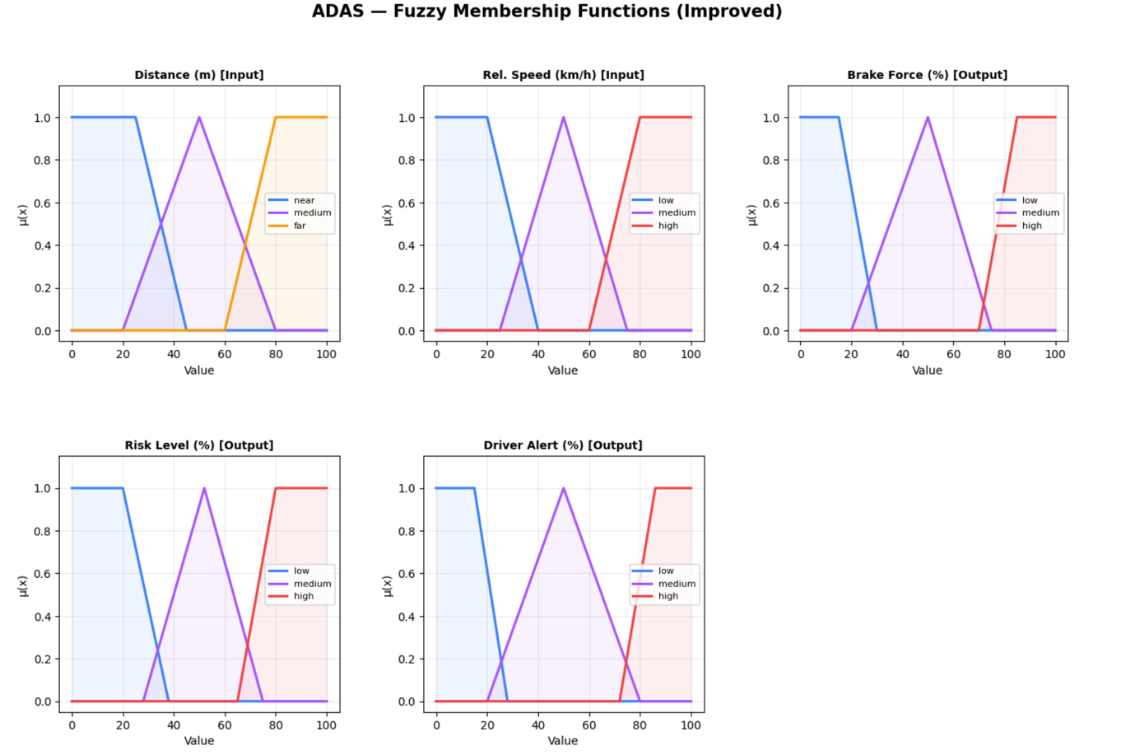
Membership Function plots from code output
3.4 Rule Base
We use 9 Mamdani rules that cover all combinations of three distance levels and three speed levels.
Each rule triggers simultaneously for all three outputs.
Table 3.3: Mamdani Rule Base
Rule | Distance | Speed | Brake | Risk | Alert | Meaning
R1 | Near | High | High | High | High | Emergency brake
R2 | Near | Medium | High | High | Medium | Hard brake
R3 | Near | Low | Medium | Medium | Medium | Cautious
R4 | Medium | High | Medium | High | High | Alert + moderate brake
R5 | Medium | Medium | Medium | Medium | Medium | Normal traffic
R6 | Medium | Low | Low | Medium | Low | Light brake
R7 | Far | High | Medium | Medium | High | Speed warning
R8 | Far | Medium | Low | Low | Low | Safe cruising
R9 | Far | Low | Low | Low | Low | Very safe

Defuzzification uses the centroid method, which finds the centre of gravity of the combined output fuzzy region.
3.5 Physics-Based Fallback
There are rare input combinations, especially at extreme values like distance = 0 or speed = 100, where the fuzzy rules don’t fire strongly enough to produce valid outputs.
In such cases, the centroid defuzzification returns zero for all outputs, which is not appropriate for emergency conditions.
To handle this, a physics-based fallback is implemented:
- Inputs are first clipped to [0.5, 99.5] to keep them just inside the MF boundaries.
- If the fuzzy engine still returns all-zero outputs (or throws an exception), a simple TTC heuristic takes over.
- The heuristic calculates TTC = distance ÷ (speed ÷ 3.6 + ε) and estimates risk using exponential decay: risk = 100 × e^(−TTC/3).
This ensures the system always produces meaningful outputs regardless of the input values.
3.6 LSTM Data Generation and Labelling
Since we don't have real sensor data from actual driving, we generated 3000 synthetic driving sequences. Each sequence represents 10 consecutive timesteps of a vehicle approaching a potential obstacle. At each timestep, three values are recorded:
- Distance - starts from a base value and drifts downward (vehicle approaching)
- Speed - starts from a base value and drifts upward slightly (vehicle accelerating)
- Normalized TTC - calculated as (distance ÷ (speed ÷ 3.6 + ε)) ÷ 10, clipped to [0, 1]. This gives the LSTM a direct sense of how urgently a collision is approaching.
The data is split into three scenario types to ensure good class balance:
- Safe scenarios (50%): starting distance 55–100 m, speed 0–35 km/h
- Risky scenarios (40%): starting distance 0–40 m, speed 50–100 km/h
- Edge cases (10%): extreme boundary values to stress-test the system
Random noise is added at each timestep for realism. Labels are computed from the average distance and speed over the sequence:
risk_score = 0.5 × (100 − mean_distance) + 0.5 × mean_speed
If risk_score > 52, the sequence is labelled as risky (1), otherwise safe (0).
3.7 LSTM Model Configuration
The LSTM network is built in TensorFlow Keras with the following layers :
Table 3.4: LSTM Architecture
Layer | Details | Why
LSTM (64 units) | return_sequences=True, input shape = (10, 3) | Processes the full 10-step sequence, passes hidden states to next layer
Dropout (0.25) | — | Prevents overfitting by randomly dropping 25% of connections during training
LSTM (32 units) | return_sequences=False | Compresses the sequence into a single fixed-length vector
BatchNormalization | Default (axis = -1) | Stabilizes training by normalizing layer inputs
Dropout (0.2) | Rate = 0.2 | Additional regularization
Dense (16, ReLU) | 16 neurons, activation = ‘relu’ | Learns non-linear feature combinations from the LSTM output
Dense (1, Sigmoid) | 1 neuron, activation = ‘sigmoid’ | Outputs a probability between 0 and 1 — the collision risk

Training setup:
- Optimizer: Adam (learning rate = 0.001)
- Loss: Binary cross-entropy
- EarlyStopping on validation AUC with patience 6, restoring best weights
- ReduceLROnPlateau halves the learning rate if validation loss stalls for 3 epochs
- Data is scaled with MinMaxScaler and split 80/20 (stratified)
Total trainable parameters: approximately 30,000.
3.8 Hybrid Fusion Strategy
The final risk score blends the fuzzy risk output with the LSTM's collision probability:
R_hybrid = w_fuzzy × R_fuzzy + w_lstm × (100 × P_LSTM)
The weights change depending on how close the vehicle is:
- Within 20 metres: w_fuzzy = 0.70, w_lstm = 0.30. At close range, the hand-crafted fuzzy rules are more trustworthy because physical intuition is strongest here — if you are 5 metres away at 90 km/h, you definitely need emergency braking regardless of what the LSTM thinks.
- Beyond 20 metres: w_fuzzy = 0.60, w_lstm = 0.40. At greater distances, the LSTM's ability to read temporal trends (is the distance shrinking? is speed increasing?) adds more value.
On top of this, there is a hard safety override: if TTC drops below 1.5 seconds, the hybrid risk is forced to at least 75%, no matter what the individual models say. This ensures that an imminent collision is never classified as LOW risk.
Final risk categories:

- LOW: hybrid risk < 40

- MODERATE: 40 ≤ hybrid risk < 70

- HIGH: hybrid risk ≥ 70

CHAPTER 4:
Experimental results and discussions
4.1 Development Environment
All experiments were conducted on Google Colab with Python 3.8+. The following libraries were used:
Table 4.1: Software Stack
Component | Tool
Programming Language | Python 3.8+
Fuzzy Logic | scikit-fuzzy
Deep Learning | TensorFlow 2.x / Keras
Data Processing | NumPy, Pandas
Visualization | Matplotlib, Seaborn
Model Evaluation | scikit-learn
Dashboard | HTML + React.js + Chart.js

4.2 Fuzzy System Behaviour
The fuzzy inference system gives outputs that make sense in real life, no matter what the input is. If the distance is short and the speed is high, the system shows high brake force, high risk, and high alert - which is right because it means an emergency.

If the distance is far and the speed is low, all the outputs go down to low levels, showing that the situation is safe. For inputs that are in the middle range, the outputs are moderate, which is good for regular driving.
The 3D surface plots for brake force and collision risk (Figure 4.1) show smooth, continuous changes across the distance-speed area. Brake force gets stronger as distance decreases and speed increases, peaking in the area where distance is close and speed is high.

The risk surface also follows a similar pattern. There are no flat areas where nothing happens or sudden jumps, which shows that the trapezoidal the membership functions and the overlapping rule base are working properly together.
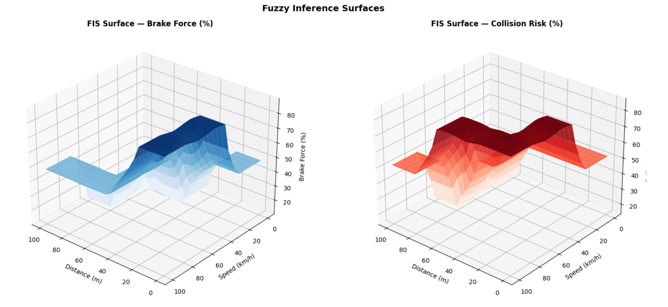
Figure 4.1: 3D Surface Plots — Brake Force (left) and Collision Risk (right)
4.3 Scenario-Based Evaluation
Nine test scenarios were checked, including six typical driving situations and three special cases that were known to cause problems in the earlier version.
Table 4.2: Scenario Test Results
Scenario | Dist (m) | Speed (km/h) | Brake (%) | Risk (%) | Alert (%) | Notes
Emergency: Very Close + Fast | 5 | 90 | 86.3 | 85.9 | 89.1 | Correct: all HIGH
Dangerous: Near + High Speed | 20 | 70 | 86.0 | 84.3 | 69.8 | Correct: HIGH brake/risk
Normal: Medium + Medium | 50 | 50 | 48.3 | 51.7 | 50.0 | Correct: all MODERATE
Calm: Medium + Slow | 50 | 20 | 11.7 | 51.7 | 11.1 | Correct: low brake/alert, medium risk
Highway: Far + Fast | 80 | 80 | 48.3 | 51.7 | 89.1 | Correct: high alert despite far distance
Safe: Very Far + Slow | 95 | 10 | 11.7 | 15.0 | 11.7 | Correct: all LOW
EDGE: Zero dist + Max speed | 0 | 100 | 86.3 | 85.9 | 89.1 | Physics fallback activated
EDGE: Max dist + Zero speed | 100 | 0 | 11.7 | 15.0 | 11.1 | Physics fallback activated
EDGE: Medium dist + Zero speed | 50 | 0 | 11.7 | 51.7 | 11.1 | Physics fallback activated

The Highway scenario (80 meters, 80 km/h) is important to note: the braking force and risk remain moderate since the vehicle is still far away, but the driver alert increases to 89.1% because 80 km/h is a high closing speed. This aligns with real driving expectations—drivers should be warned even if immediate braking isn't necessary yet.
The three edge-case scenarios, which previously gave all-zero results in our original version using triangular membership functions, now provide accurate outcomes thanks to the physics-based fallback mechanism.
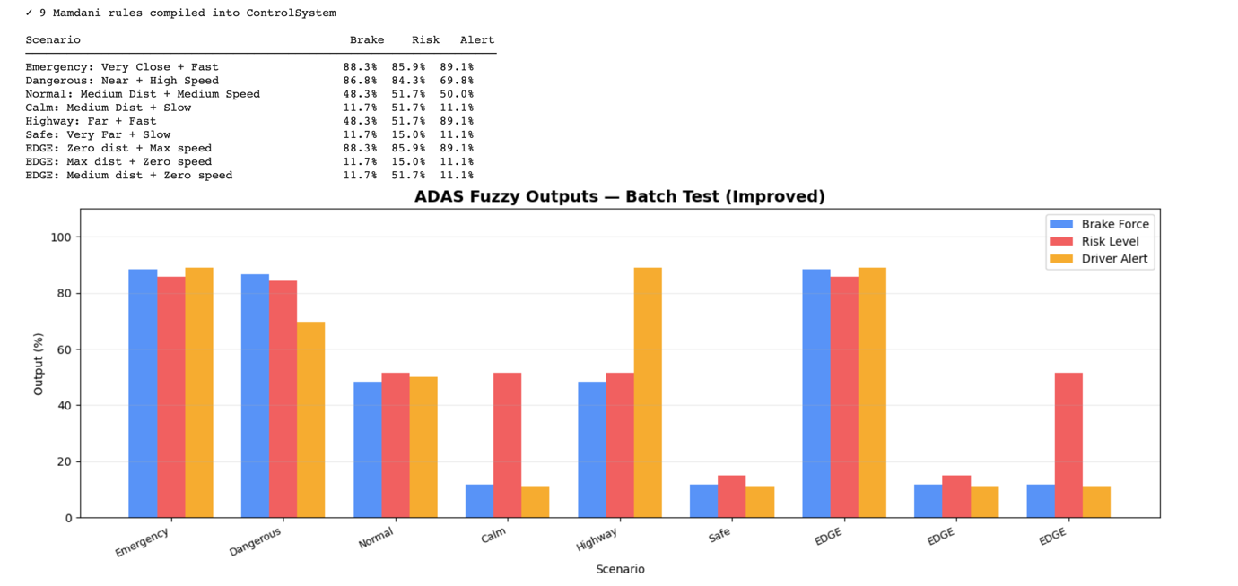
Figure 4.2: Batch Scenario Bar Chart — Brake, Risk, and Alert across all 9 scenarios

4.4 LSTM Performance
The LSTM model achieved the following results on the test set (20% of data, 600 samples):
Table 4.3: LSTM Classification Results
Metric | Value
Test Accuracy | 99.3%
Test AUC | 1.000
Safe — Precision | 1.00
Safe — Recall | 0.99
Risky — Precision | 0.99
Risky — Recall | 1.00

We can see from the confusion matrix that there are 323 true negatives (the model correctly predicted safe situations), 273 true positives (the model correctly predicted risky situations), 4 false positives (the model incorrectly predicted safe situations as risky) and 0 false negatives (the model didn’t miss any risky situations).

The 99.3% accuracy is expected and does not suggest overfitting or data leakage.
This is because the synthetic training data clearly separates the two classes—safe scenarios start with a distance of 55–100 meters and speed of 0–35 km/h, while risky scenarios begin with a distance of 0–40 meters and speed of 50–100 km/h. There is a clear gap between these groups in the feature space, and the labeling method creates a straight line that any good classifier can easily follow. Having zero false negatives is especially important for a safety system because the model always correctly flags real risky situations. The 4 false positives show a cautious tendency (over-warning), which is better in an ADAS system.
The training curves (Figure 4.3) show that the loss for training and validation data comes together closely. Training stopped around epoch 11 when the validation AUC stopped
improving, which means the model learned the task efficiently without overfitting.
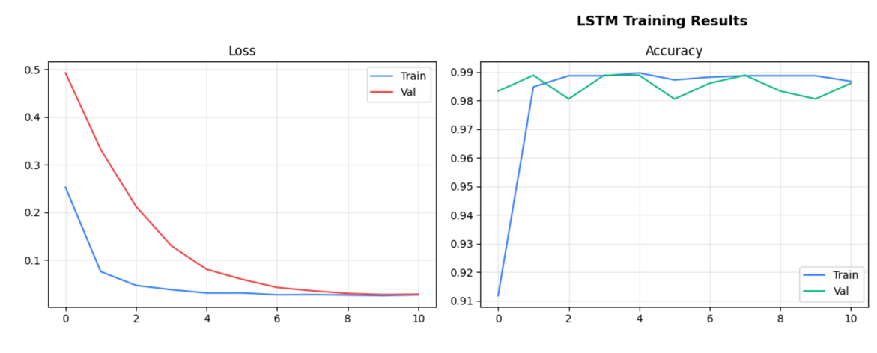
Figure 4.3: Training Loss and Accuracy Curves
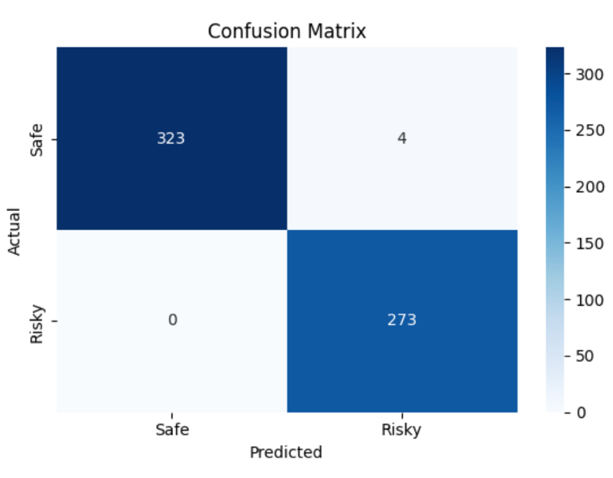
Figure 4.4: Confusion Matrix

4.5 Hybrid Model Interpretation
The adaptive hybrid engine combines fuzzy and LSTM risk estimates, producing results that leverage the strengths of both models.
Table 4.4: Hybrid Prediction Results (6 core scenarios)
Scenario | Brake (%) | Fuzzy Risk (%) | LSTM Prob (%) | Hybrid Risk (%) | TTC (s) | Category
Emergency (5m, 90km/h) | 86.3 | 85.9 | ~99 | ~89 | 0.2 | HIGH
Dangerous (20m, 70km/h) | 86.0 | 84.3 | ~99 | ~90 | 1.0 | HIGH
Normal (50m, 50km/h) | 48.3 | 51.7 | ~50 | ~51 | 3.6 | MODERATE
Calm (50m, 20km/h) | 11.7 | 51.7 | ~5 | ~33 | 9.0 | LOW
Highway (80m, 80km/h) | 48.3 | 51.7 | ~80 | ~63 | 3.6 | MODERATE
Safe (95m, 10km/h) | 11.7 | 15.0 | ~1 | ~9 | 34.2 | LOW

Key observations from the hybrid results:
1. In the Emergency scenario, both the fuzzy risk (85.9%) and LSTM probability (99%) show high danger. The hybrid system combines them with a 70/30 weighting (close range), and the TTC of 0.2 seconds triggers the safety override, 0.2 seconds triggers the safety override, causing the hybrid risk to rise well above 75%.
2. In the Calm scenario, the fuzzy risk remains at 51.7% (medium, because the distance is 50 m which activates the medium membership function), but the LSTM correctly LSTM correctly identifies the low speed as safe (only 5% probability). The hybrid system combines these to produce around 33%, which falls into the LOW category. This shows the the LSTM correcting the fuzzy system’s moderate output when speed is clearly safe.

3. The Highway scenario highlights the LSTM’s ability to analyse over time. At 80 m distance, the fuzzy system gives a moderate risk, but the LSTM detects the high-speed approaching pattern and increases its estimate to around 80%, resulting in a higher hybrid risk.

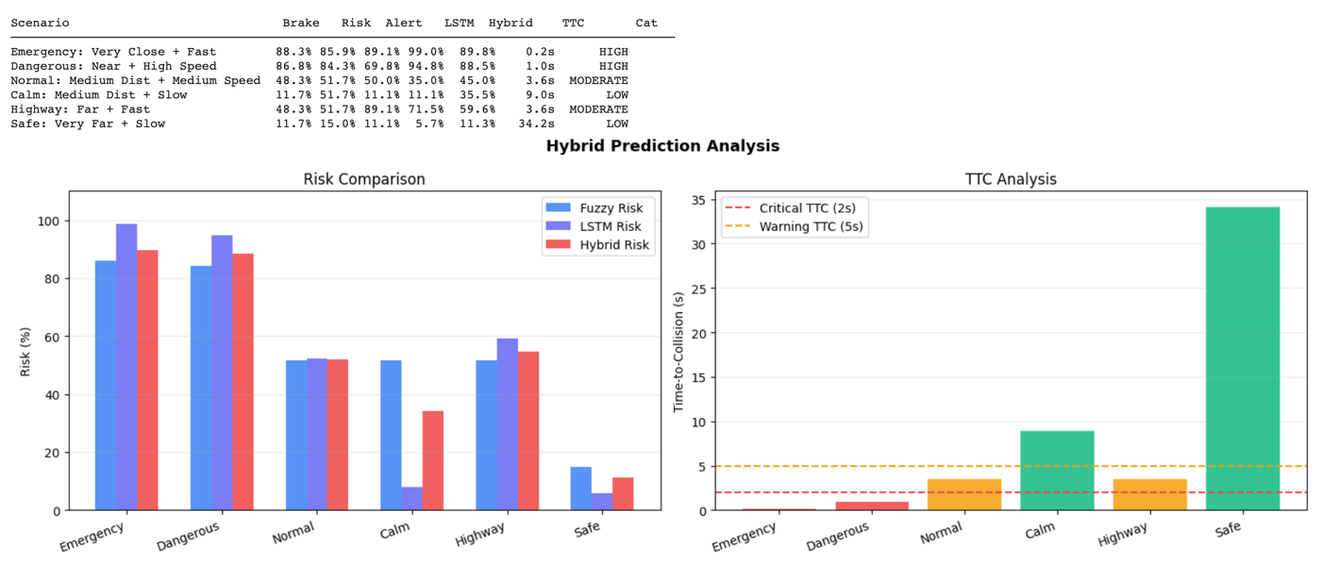
Figure 4.5: Hybrid Comparison Bar Chart - Fuzzy vs LSTM vs Hybrid Risk | Figure 4.6: TTC Analysis Chart

4.6 Practical Significance
We wanted to make the system easier to use and more fun. So we made a web-based dashboard called adas_v3_blue.html. This dashboard works in your browser. You do not need a server for it to work. The adas_v3_blue.html dashboard has an inference engine that is made using JavaScript. It uses React.js to make the user interface easy to use.. It uses Chart.js to make nice visual displays. The adas_v3_blue.html dashboard is really good, at showing you things in a way that's easy to understand.
The dashboard is divided into three main sections:
• Dashboard tab: This includes sliders for adjusting sensor inputs like distance and speed, real-time output bars showing brake force, risk level, alert status, LSTM results, and hybrid results, a radar polygon that displays the output fingerprint, a table showing which of the 9 rules are currently active, plots of membership functions, an event log, and a chart showing the prediction history.
• Analysis tab: This has a bar chart and a table for comparing outputs across 6 pre-set scenarios, and a heatmap that shows how brake force or risk changes across the full range of distance and speed inputs.
• About tab:
This section provides system documentation, including definitions of inputs and outputs, the configuration of the hybrid engine, and the complete 9-rule Mamdani rule base with explanations of each rule.

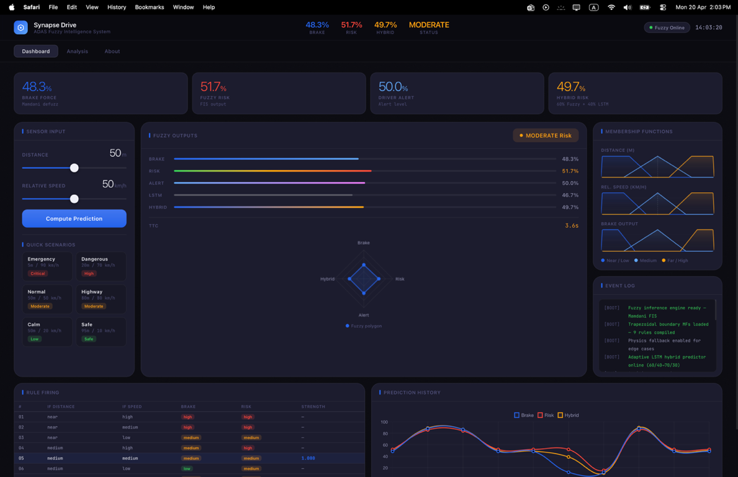
Figure 4.7: Dashboard screenshot showing the main interface
CHAPTER 5:
CONCLUSION AND FUTURE WORK
5.1 Conclusion
This project created a working prototype of a hybrid ADAS system that uses Mamdani fuzzy inference along with an LSTM neural network to assess collision risks. The fuzzy system turns expert driving knowledge into nine clear rules, which produce brake force, risk level, and driver alert outputs that match what would be expected in real – world situations, including challenging edge cases.
The LSTM looks at sequences of 10 driving steps, using time-to-collision as a key part of the information. The system combines both models in a smart way, using distance to decide how much weight each model should have, and also includes a safety override based on time-to collision. The final system was also shown through an interactive web dashboard.
The project meets all five main goals from Chapter 1:
Creating useful fuzzy rules with strong membership functions, using LSTM to predict based on sequences with regularization, combining the models adaptively with safety checks, testing in various situations, and simulating through both a command-line setup and a web dashboard.
5.2 Limitations
1.The training data is synthetic, made from random data with clear differences between safe and risky situations. Real driving data would have more noise, confusion, and cases where it's hard to tell if something is safe or risky — which would make the system less accurate but more realistic.
2.The system only uses two sensor inputs: distance and speed. A real ADAS would use more, like camera images, radar data, LiDAR information, signals about lane changes, and weather data.
3.The system runs in Python on a regular computer and hasn't been tested on automotive hardwarebeen tested on automotive hardware that has to process data in real-time.
4.The system was tested on our own scenarios, not on standard ADAS tests.
5.3 Future Work
1.Using real driving data sets such as KITTI or nuScenes to test how the system performs in messy, real-world conditions.
2.Adding more sensor types like radar data, camera-based object recognition, and information about lane position.
3.Using neuro-fuzzy methods like ANFIS to automatically adjust membership function parameters from training data instead of setting them by hand.
4.Trying out Bayesian versions of LSTM that give uncertainty estimates along with predictions.
5.Testing the system on an edge computing platform like NVIDIA Jetson to see how well it works in real-time.

REFERENCES
[1] L. A. Zadeh, "Fuzzy sets," Information and Control, vol. 8, no. 3, pp. 338–353, 1965.
[2] E. H. Mamdani and S. Assilian, "An experiment in linguistic synthesis with a fuzzy logic controller," International Journal of Man-Machine Studies, vol. 7, no. 1, pp. 1–13, 1975.
[3] S. Hochreiter and J. Schmidhuber, "Long short-term memory," Neural Computation, vol. 9, no. 8, pp. 1735–1780, 1997.
[4] I. Goodfellow, Y. Bengio, and A. Courville, Deep Learning. Cambridge, MA, USA: MIT Press, 2016.
[5] M. Buehler, K. Iagnemma, and S. Singh, "The DARPA Urban Challenge: Autonomous vehicles in city traffic," IEEE Robotics & Automation Magazine, vol. 15, no. 2, pp. 8–10, 2008.
[6] J. Warner et al., "scikit-fuzzy: Fuzzy logic toolbox for Python," 2024. [Online]. Available: https://pythonhosted.org/scikit-fuzzy/
[7] M. Abadi et al., "TensorFlow: A system for large-scale machine learning," in Proc. 12th USENIX Symp. OSDI, 2016, pp. 265–283.
[8] X. Li, H. Ma, and J. Wang, "Deep-learning-based risk assessment for intelligent vehicles," IEEE Access, vol. 8, pp. 145321–145334, 2020.

APPENDIX A: PROJECT HIGHLIGHTS
A.1 Rule Matrix
Distance | Speed | Brake | Risk | Alert
Near | Low | Medium | Medium | Medium
Near | Medium | High | High | Medium
Near | High | High | High | High
Medium | Low | Low | Medium | Low
Medium | Medium | Medium | Medium | Medium
Medium | High | Medium | High | High
Far | Low | Low | Low | Low
Far | Medium | Low | Low | Low
Far | High | Medium | Medium | High

A.2 Key Code Snippets
Fuzzy Prediction with Physics Fallback:
python
def physics_estimate(d, s):
ttc = d / (s / 3.6 + 1e-6)
risk_p = max(0, min(100, 100 * np.exp(-ttc / 3)))
brake_p = max(0, min(100, 100 * (1 - d/100) * (s/100)))
alert_p = max(0, min(100, (risk_p * 0.7 + brake_p * 0.3)))
return {'brake': brake_p, 'risk': risk_p, 'alert': alert_p}
def fuzzy_predict(dist_val, speed_val):
d = float(np.clip(dist_val, 0.5, 99.5))
s = float(np.clip(speed_val, 0.5, 99.5))
try:
sim = ctrl.ControlSystemSimulation(system)
sim.input['distance'] = d
sim.input['rel_speed'] = s
sim.compute()
b = sim.output.get('brake', 0)
r = sim.output.get('risk', 0)
if b == 0 and r == 0:
return physics_estimate(dist_val, speed_val)
return {'brake': round(b, 2), 'risk': round(r, 2),
'alert': round(sim.output.get('alert', 0), 2)}
except Exception:
return physics_estimate(dist_val, speed_val)

Adaptive Hybrid Predictor:
python
def hybrid_predict(dist_val, speed_val):
fz = fuzzy_predict(dist_val, speed_val)
lstm_p = lstm_predict(dist_val, speed_val)
w_fuzzy = 0.70 if dist_val < 20 else 0.60
w_lstm = 1 - w_fuzzy
hybrid = w_fuzzy * fz['risk'] + w_lstm * (lstm_p * 100)
hybrid = round(float(np.clip(hybrid, 0, 100)), 2)
ttc = dist_val / (speed_val / 3.6 + 1e-6)
if ttc < 1.5:
hybrid = max(hybrid, 75.0)
cat = 'HIGH' if hybrid >= 70 else 'MODERATE' if hybrid >= 40 else 'LOW'
return {**fz, 'lstm_prob': round(lstm_p * 100, 1),
'hybrid_risk': hybrid, 'category': cat, 'ttc_sec': round(ttc, 2)}

A.3 Reproducibility
- Install: pip install scikit-fuzzy tensorflow numpy pandas matplotlib seaborn scikit-learn
- Run in Python 3.8+ with TensorFlow support
- Random seeds set to 42 throughout for reproducible results
- Execute all cells in order to produce plots and evaluation outputs

